CSIT314 Software Development Methodologies - Group Project

Sprint 5 - US38: View IDP save statistics
Interior Design Platform - Interior Designer
All diagrams were drawn in draw.io. Open "US38 View IDP save statistics.drawio" in this folder to edit them - each diagram is its own page in that file. The exported images are in the "diagrams" folder.

Assumptions
- The system is the Interior Design Platform from the project specification. Sprint 5 covers the Interior Designer's IDP statistics stories (view statistics US37 and save statistics US38) and the Platform Manager's daily, weekly and monthly category report stories (US46 - US48).
- We follow B-C-E: the actor only talks to the boundary (page), the boundary only talks to the controller, and the controller works with the entity classes. There is one controller per use case.
- The boundary checks all the input (required fields, lengths, formats, e.g. not suspending your own profile) and trims spaces, then passes an entity object on. The controller just calls the entity and returns the result. The entity checks for duplicates and the database state (e.g. name already used, only Active rows are changed), then saves. In US38 there is no typed input: the page takes designerId from the session, the controller just calls the entity, and the entity only returns the designer's own Active IDPs with their saves.
- An IDP is an interior design project of the designer, current (US20 - US24) or past (US25 - US29). IDPAnalytics is the entity for the IDP statistics and reports (US37, US38, US46 - US48): one IDPAnalytics object is one row of the statistics table (idpId, title, projectType, categoryName and views or saves).
- Logged in as an Interior Designer (UC13) is the precondition. designerLoginRequired in app.py only sends someone with no session to /designer/login; the use case doesn't check the designer again (no InteriorDesignerLoginController).
- Saves come from the saved_idp table, which UC33 Save IDP fills (SavedIDP.createSavedRecord). saves is the number of different customers who saved the IDP, so each customer is counted once. Views (US37) don't count as saves.
- The table lists every one of the designer's Active IDPs (current and past) with its category, type and number of customers who saved it - 0 if nobody has - most saved first (ties by title). Deleted (Suspended) IDPs and other designers' IDPs are not shown.
- No Active IDPs is a normal page with MSG_NO_IDPS "You don't have any active IDPs yet, so there are no saves to show" instead of the table.
- Viewing the statistics is read-only. The Views tab on the same page is US37.

1. User story
Story ID | US38
User story | As an interior designer, I want to see how many users have saved each of my IDPs so that I can tell which IDPs people are interested in.
Actor | Interior Designer
Priority | Medium
Story points (estimate) | 2
Acceptance criteria | 1. Given I am logged in as an interior designer, when I open IDP Statistics and click the "Saves" tab, then I see a table of my own Active IDPs - IDP, Category, Type and Customers who saved it - most saved first.  2. Given a customer saves one of my IDPs (UC33), when I open the Saves tab again, then its number has gone up by one.  3. Given the same customer saves that IDP again, then it is still counted once.  4. Given nobody has saved one of my IDPs, then it is listed with 0 (views don't count as saves).  5. Given I have no Active IDPs, then I see "You don't have any active IDPs yet, so there are no saves to show" and no table.  6. Deleted IDPs and other designers' IDPs are never shown, and opening the statistics changes nothing.
Tasks | #267 Draw Use Case Diagram and Write Use Case Description  #272 Design Wireframe  #277 Write and Execute Test Cases  #282 Draw BCE and Sequence Class Diagram  #284 Implement the save statistics function to display the number of customers who saved each of the designer's projects.

2. Use case diagram
The user story becomes one use case, UC38 View IDP save statistics. The Interior Designer is the only actor. The statistics table and the "no IDPs" message are flows of this use case. The saves it counts are made by customers in UC33 Save IDP.
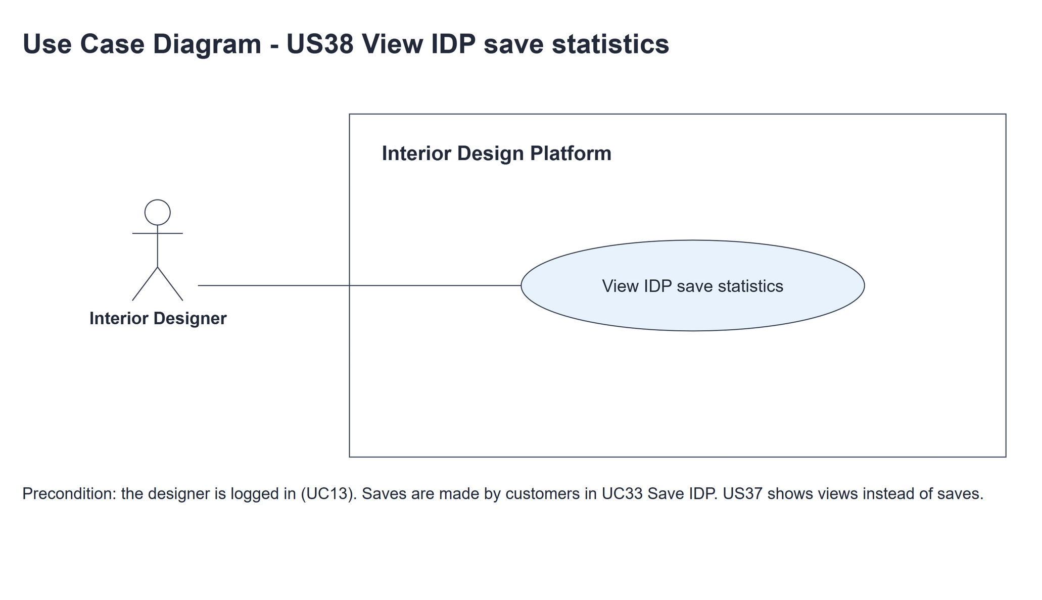
Figure 1: Use case diagram for US38 View IDP save statistics

3. Use case description
Use case | UC38 View IDP save statistics
Actor | Interior Designer
Brief description | The Interior Designer sees how many different customers have saved each of their Active IDPs, most saved first.
User story | US38: As an interior designer, I want to see how many users have saved each of my IDPs so that I can tell which IDPs people are interested in.
Preconditions | Logged in as an Interior Designer (UC13). designerLoginRequired in app.py only sends someone with no session to /designer/login.
Trigger | The Interior Designer clicks the "Saves" tab on the IDP Statistics page.
Basic flow | 1. The Interior Designer clicks the "Saves" tab.  2. The system gets the designer's Active IDPs, each with the number of different customers who saved it (0 if none), most saved first.  3. The system shows the table - IDP, Category, Type and Customers who saved it - with the hint "Each customer who saved the IDP is counted once."
Alternative flows | 2a. The designer has no Active IDPs: the system shows "You don't have any active IDPs yet, so there are no saves to show" and no table. The use case ends.
Postconditions | Nothing is changed - no IDP and no customer's saved list.

4. Wireframes
The wireframes were drawn in draw.io from the real page (templates/idpStatistics.html in the designer layout). They are low-fidelity: they show the layout and the flow, not the final colours. The orange numbers match the notes under each screen.

4a - Statistics table
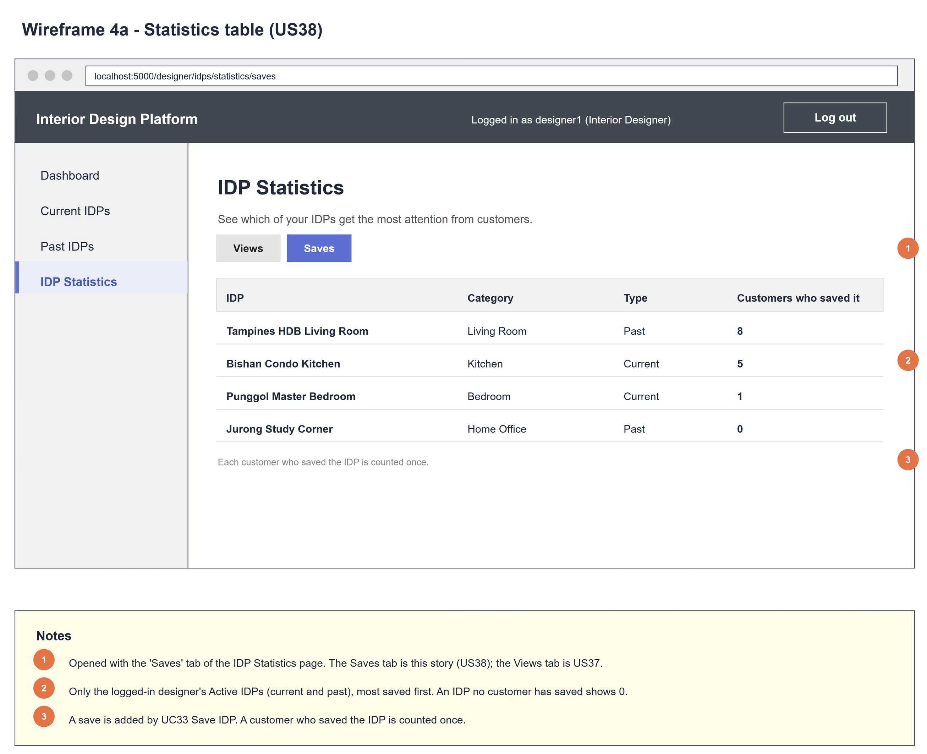
Figure 2: Wireframe 4a - Statistics table (US38)

4b - No IDPs yet
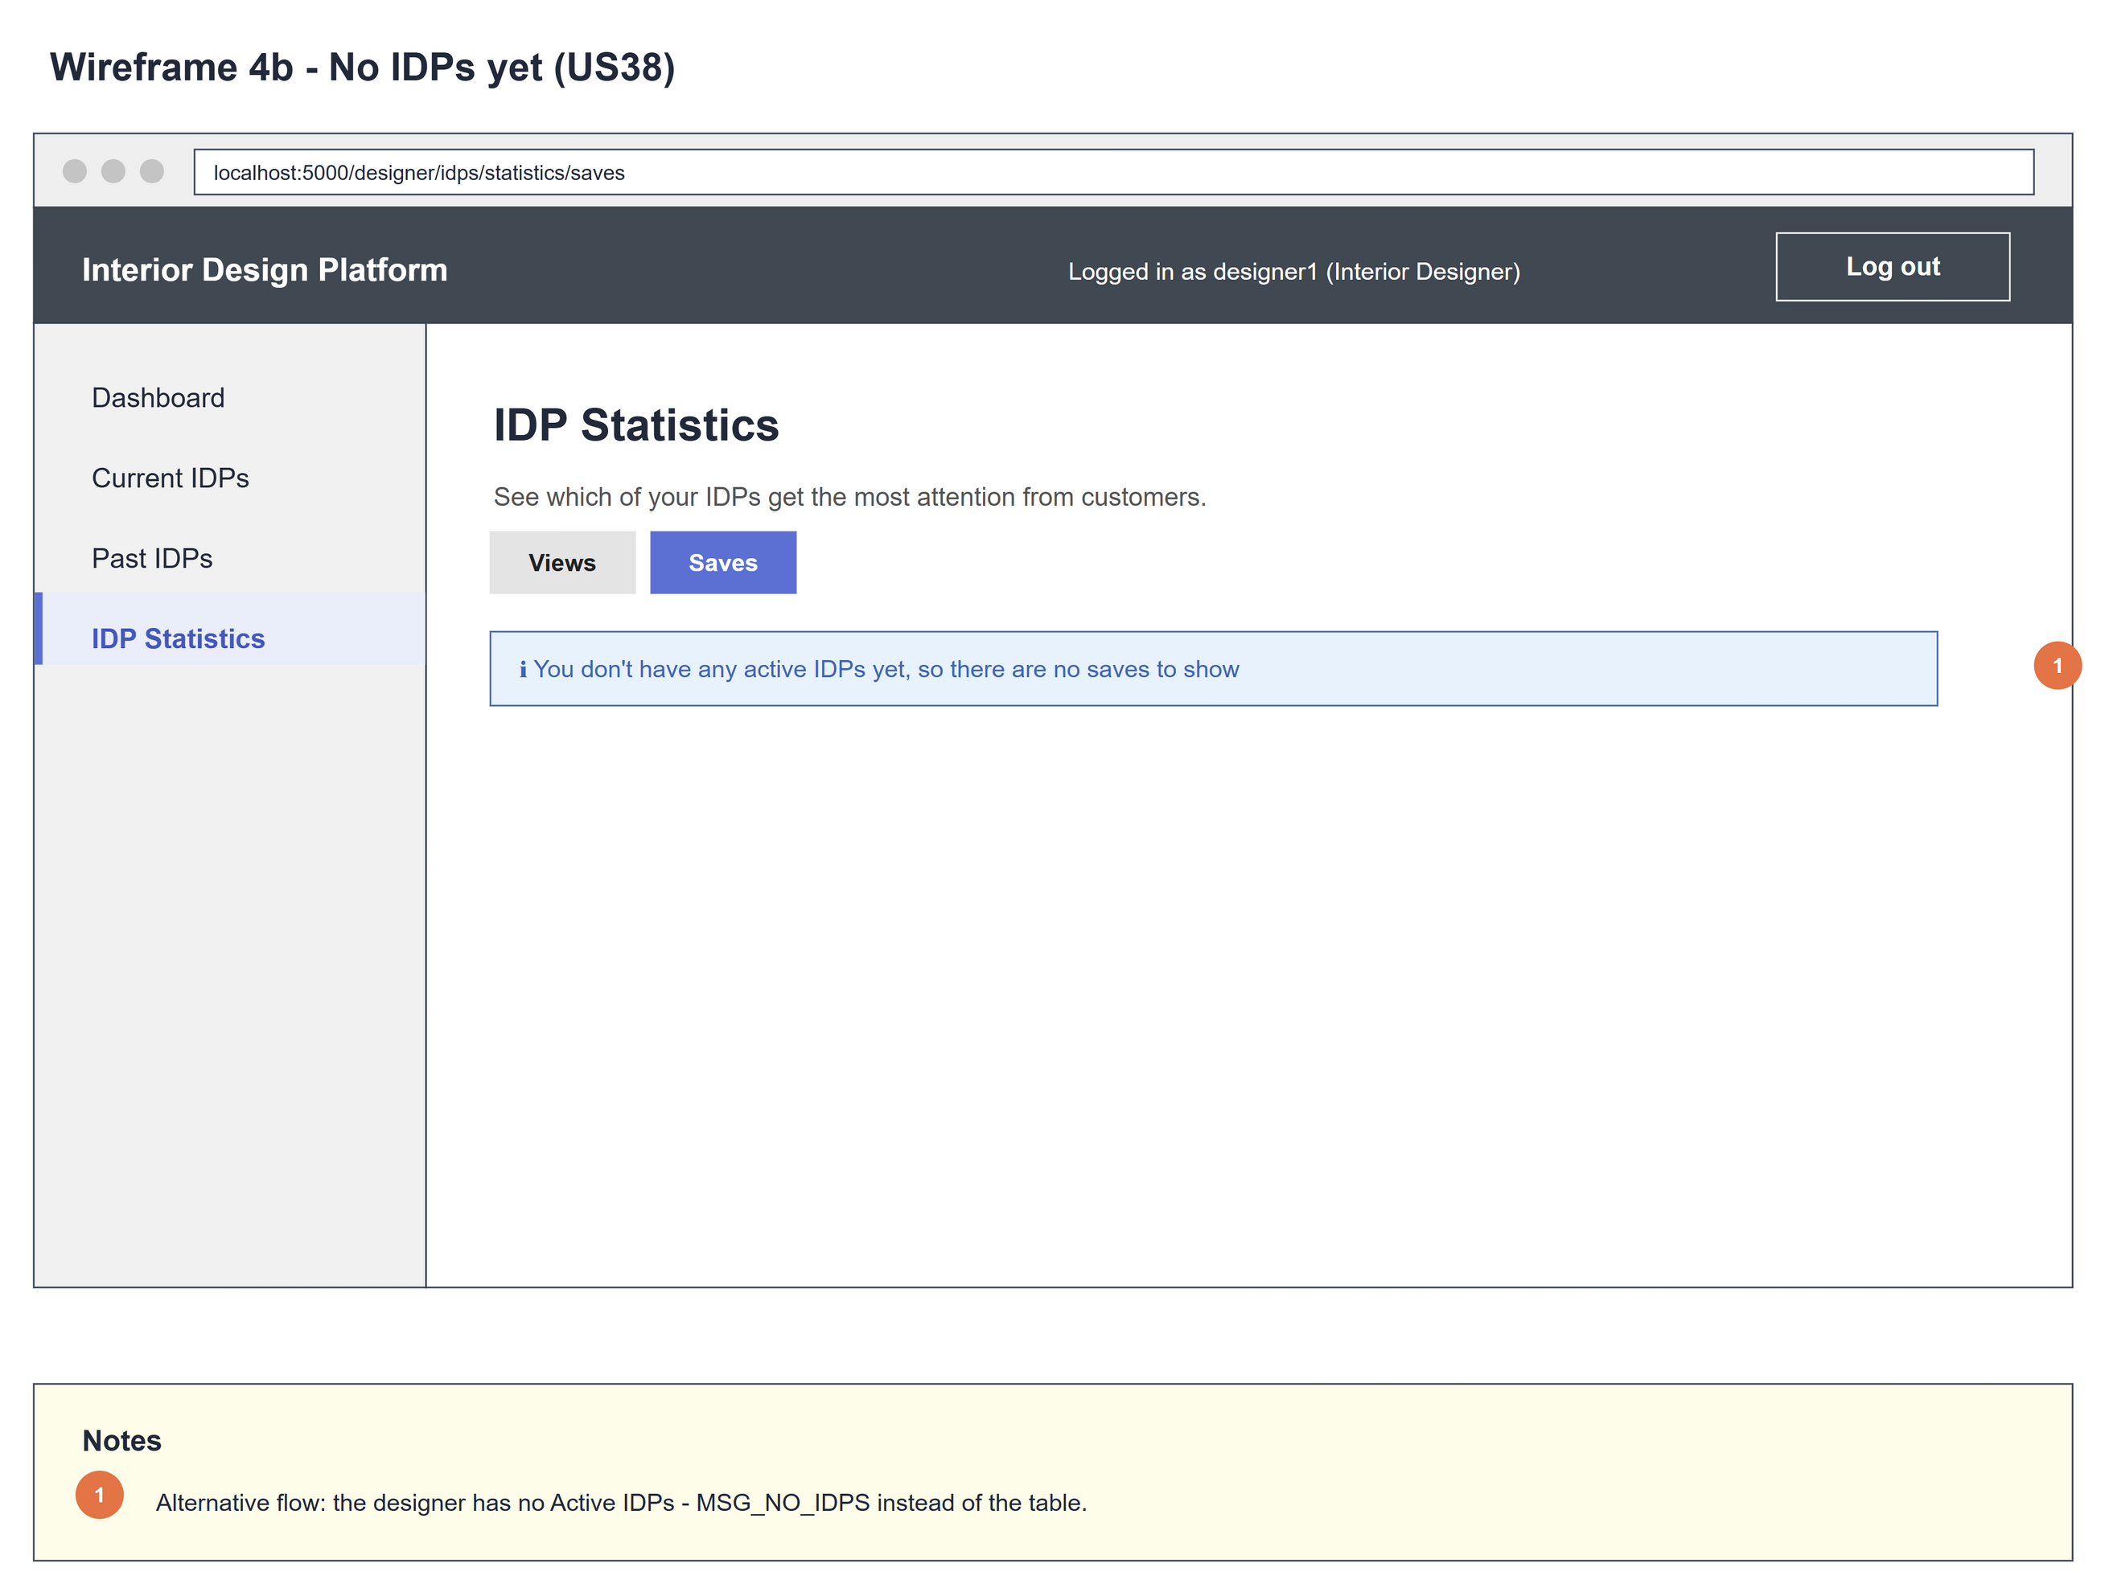
Figure 3: Wireframe 4b - No IDPs yet (US38)

5. B-C-E class diagram
The solid line means the boundary calls the controller. The dashed line means the controller uses the entity. Only the operations needed for this use case are shown. The IDPAnalytics box lists all its attributes (the same box is in US37, US38 and US46 - US48) but only the US38 method.
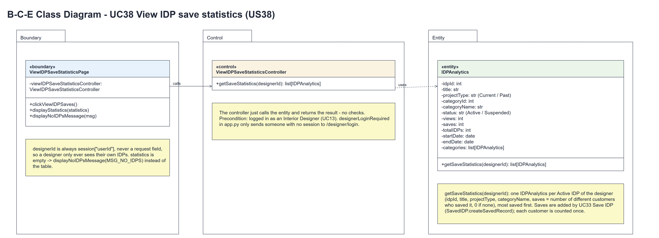
Figure 4: B-C-E class diagram for US38 View IDP save statistics
Layer | Class | What it does
Boundary | ViewIDPSaveStatisticsPage | The Saves tab of the IDP Statistics page. clickViewIDPSaves() calls getSaveStatistics(designerId) with designerId = session userId. If statistics is empty it shows displayNoIDPsMessage(MSG_NO_IDPS), otherwise displayStatistics(statistics) (the table, most saved first).
Control | ViewIDPSaveStatisticsController | Controller for UC38. getSaveStatistics(designerId) just calls the entity and returns its list[IDPAnalytics] unchanged - no checks.
Entity | IDPAnalytics | The only entity. getSaveStatistics(designerId) returns one IDPAnalytics per Active IDP of the designer (idpId, title, projectType, categoryName, saves = number of different customers who saved it, 0 if none), most saved first. Saves are added by UC33 Save IDP (SavedIDP.createSavedRecord).

6. Sequence diagram
The sequence diagram follows UC38. Clicking the "Saves" tab (clickViewIDPSaves()) calls getSaveStatistics(designerId) with designerId = session userId; the controller makes one call to IDPAnalytics.getSaveStatistics(designerId) and returns statistics unchanged (steps 1-5, basic flow 1-2). The alt then shows displayNoIDPsMessage(MSG_NO_IDPS) when statistics is empty (steps 6-7, alternative flow 2a, wireframe 4b) or displayStatistics(statistics) when it is not empty (steps 8-9, basic flow 3, wireframe 4a). There is no typed input, so there is no input check. Saves are added by UC33 Save IDP (SavedIDP.createSavedRecord); each customer is counted once.
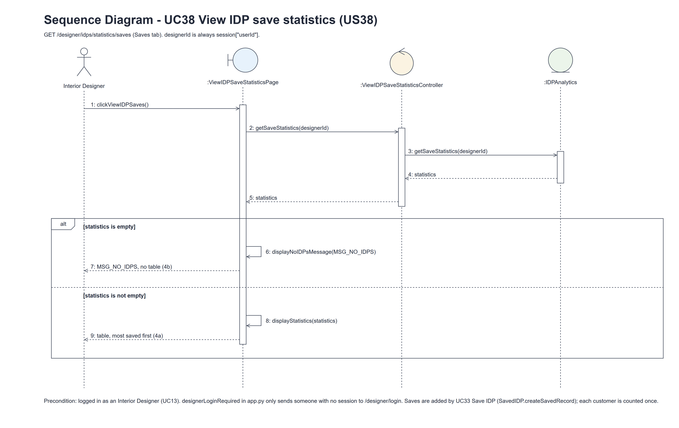
Figure 5: Sequence diagram for UC38 View IDP save statistics

7. Test cases
Test data used below (the same as tests/test_us38_viewIDPSaveStatistics.py, which reuses the US37 helpers): designer accounts designer37 (A) and designer37b (B) / Design@123, made with UC8, and the customers cust001 and cust038 / Cust@123. IDP category Kitchen (Active). A owns the Active IDPs "Modern Kitchen" (Current) and "Old Kitchen" (Past) and a deleted (Suspended) IDP "Deleted Kitchen"; B owns "Someone Else's Kitchen". A save is one saved_idp row, added when a customer clicks Save (UC33).

7a. System test cases (black box)
Equivalence partitioning and boundary value analysis were used to pick the test data. The team runs these by hand: fill in "Actual result" and "Pass/Fail" after running each test.
Test ID | Scenario | Prerequisites | Test steps | Test data | Expected result | Actual result | Pass / Fail
TC38.1 | View my save statistics | Logged in as A. cust001 and cust038 have saved Modern Kitchen; nobody has saved Old Kitchen. | 1. Click "IDP Statistics"  2. Click "Saves" | A's and B's IDPs above | Saves tab: Modern Kitchen (2), then Old Kitchen (0), with category and type - not the deleted or B's IDP. Hint "Each customer who saved the IDP is counted once."
TC38.2 | A customer save is counted | TC38.1 done. | 1. Log in as cust001, open Old Kitchen and click Save (UC33)  2. Log in as A and open the Saves tab | - | Old Kitchen now shows 1.
TC38.3 | Saving again counts once | TC38.2 done. | 1. As cust001, click Save on Old Kitchen again  2. As A, open the Saves tab | - | Old Kitchen still shows 1.
TC38.4 | Views are not saves | Logged in as A. Old Kitchen opened 5 times by cust038, not saved by them. | 1. Open the Saves tab | - | Old Kitchen's number doesn't change.
TC38.5 | No Active IDPs | Logged in as a designer whose only IDP is deleted (or who has none). | 1. Open the Saves tab | - | "You don't have any active IDPs yet, so there are no saves to show"; no table.
TC38.6 | Views and Saves tabs | Logged in as A. | 1. Open the Saves tab  2. Click "Views" | - | The Saves tab is highlighted; "Views" opens the US37 view statistics.
TC38.7 | Not logged in | Not logged in. | 1. Open /designer/idps/statistics/saves | - | The designer login page is shown.

7b. Unit test cases (for TDD)
These are written before the code (test-driven development) and run with pytest (python -m pytest). They cover normal inputs, abnormal inputs and boundary values. Each one matches a test function in tests/test_us38_viewIDPSaveStatistics.py (UT38.1 is test_ut38_1_...). "Pass" is from the pytest run on 10 November 2026.
Test ID | Class and method | Input / setup | Expected output | Type | Pass / Fail
UT38.1 | IDPAnalytics.getSaveStatistics(designerId) | A has no IDPs | [] (empty list) | Boundary | Pass
UT38.2 | IDPAnalytics.getSaveStatistics(designerId) | A: Modern Kitchen saved by cust001 and cust038, Old Kitchen (Past) saved by nobody | Modern Kitchen saves == 2 and Old Kitchen saves == 0 (read as row.idpId / row.saves) | Normal | Pass
UT38.3 | IDPAnalytics.getSaveStatistics(designerId) | A's Own Kitchen; B's IDP saved by cust001 | Only A's IDP (row.idpId == Own Kitchen) | Abnormal | Pass
UT38.4 | IDPAnalytics.getSaveStatistics(designerId) | A's only IDP is deleted (Suspended) | [] | Abnormal | Pass
UT38.5 | IDPAnalytics.getSaveStatistics(designerId) | A Kitchen viewed 5 times and never saved; B Kitchen saved by cust001 | [(B Kitchen, 1), (A Kitchen, 0)] as (row.idpId, row.saves) - most saved first, views don't count | Normal | Pass
UT38.6 | SavedIDP.createSavedRecord(customerId, idpId) (UC33), then IDPAnalytics.getSaveStatistics(designerId) | cust001 saves Modern Kitchen twice | statistics[0].saves == 1 - each customer is counted once | Boundary | Pass
UT38.7 | ViewIDPSaveStatisticsController.getSaveStatistics(designerId) | A's Modern Kitchen saved by cust001 | Same idpId and saves as IDPAnalytics().getSaveStatistics(designerId) (compared by attributes) | Normal | Pass
UT38.8 | ViewIDPSaveStatisticsPage.clickViewIDPSaves() / displayStatistics(statistics) | A's Modern Kitchen saved by cust001; A logged in | HTTP 200; "Modern Kitchen", the column "Customers who saved it" and <strong>1</strong> | Normal | Pass
UT38.9 | ViewIDPSaveStatisticsPage.displayNoIDPsMessage(msg) | A has no IDPs | MSG_NO_IDPS is shown; no table | Boundary | Pass
UT38.10 | /designer/idps/statistics/saves (designerLoginRequired) | Not logged in | Redirects to /designer/login | Abnormal | Pass
UT38.11 | IDP Statistics tabs | A opens the Saves tab | Links to /designer/idps/statistics/views and /designer/idps/statistics/saves | Normal | Pass
UT38.12 | ViewIDPSaveStatisticsPage.displayStatistics(statistics) | A's Modern Kitchen saved by cust001; A logged in | Hint "Each customer who saved the IDP is counted once." under the table | Normal | Pass

